Walcires Fernando
ST10459259
11/1/2025
Walcires Fernando

Practicum IMAD5112

Vc Online
Term 2

Retail Quantity Tracking Application

App Runing
Main screen
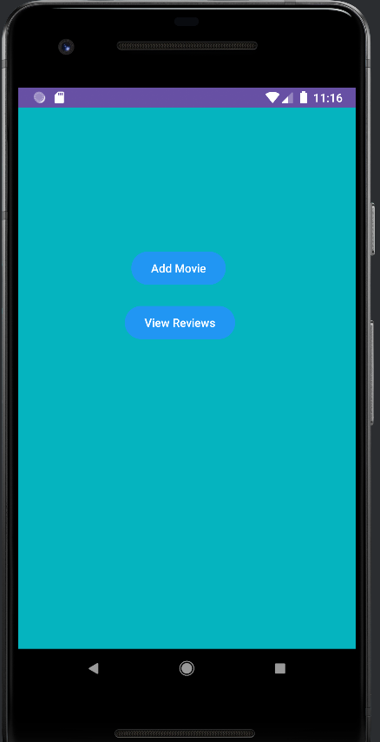

Add Movie Button
- Allow the user to add new movies to the list.
- Each movie includes title, director, rating, and comment.
- Data is stored in parallel arrays within the app.

View Reviews Button
- Let’s the user view all added movies.
- Opens Detail Activity, displaying the title, director, rating, and comment for each movie.

Detail Screen
- Displays the full list of movies added in the app.
- Each movie shows:
  - Title
  - Director
  - Rating
  - Comment
- The screen is dynamic, so any new movie added via the Add Movie Button will automatically appear here.
- Uses a scrollable layout to handle multiple movies.

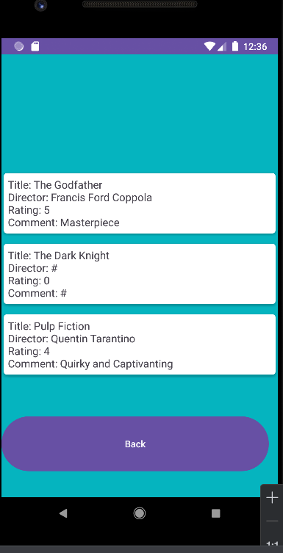

Back Button
- Allows the user to return from the Detail Activity to the Main Activity.
- Provides easy navigation and improves user experience by letting them go back to add or view more movies.

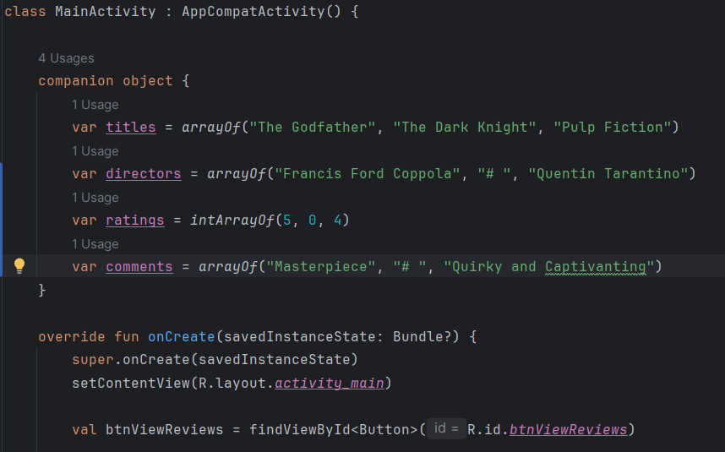

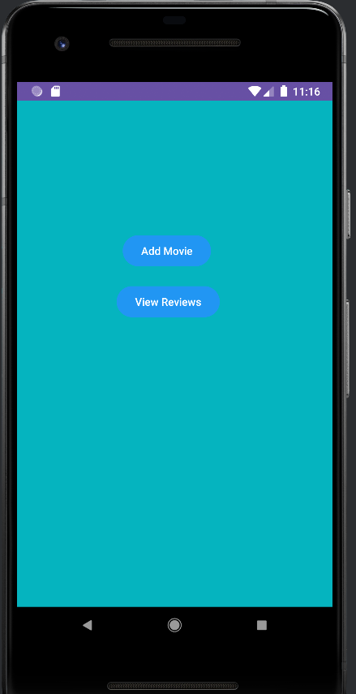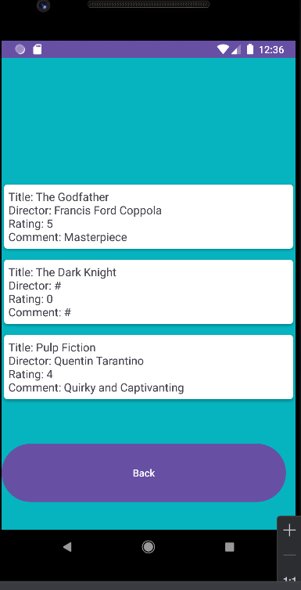

Splash Scree cod :
